**Project Report**

**Name: Anthony Golubski-Allen**

**Email:** [**adgolubs@iupui.edu**](mailto:adgolubs@iupui.edu)

**Student ID: 0003331909**

**Project: Smart Fire Alarm**

**Course: CSCI 49000 Internet of Things**

**Date: 12/11/17**

**Introduction**

* Project Description

The focus of this project is to develop a smart fire alarm system. This system will utilize the flame sensor and the buzzer sensor. It will also utilize a web service called Twilio. Twilio is a web service that will allow the fire alarm system to send text messages to the user. The Twilio API sends the phone data to the Twilio website to send the text message. I will be using an Indiana phone number given by Twilio for the fire alarm system.

The fire alarm system will use the flame sensor to detect the fire. If the system detects a fire, it will send a text message to the user that there is a fire. The fire alarm system will also use the buzzer sensor to make noise when there is a fire. Once the fire is put out, the buzzer will stop making the noise. The system will also send a text message saying that the fire has been put out.

**System design**

-Circuit Schematic

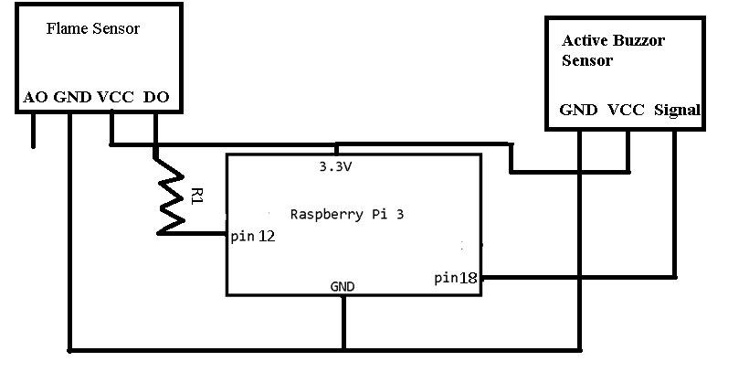

**-**Description

This system uses the flame sensor that has analog and digital output. I used digital output instead of analog output to get the signal from the flame sensor. This system uses a buzzer sensor that turns on when the flame sensor detects a fire. That is when the user will get a text message saying there is a fire. The buzzer sensor turns off when the fire sensor does not detect a fire and the user gets another message saying that the fire has been put out.

**Implementation**

* 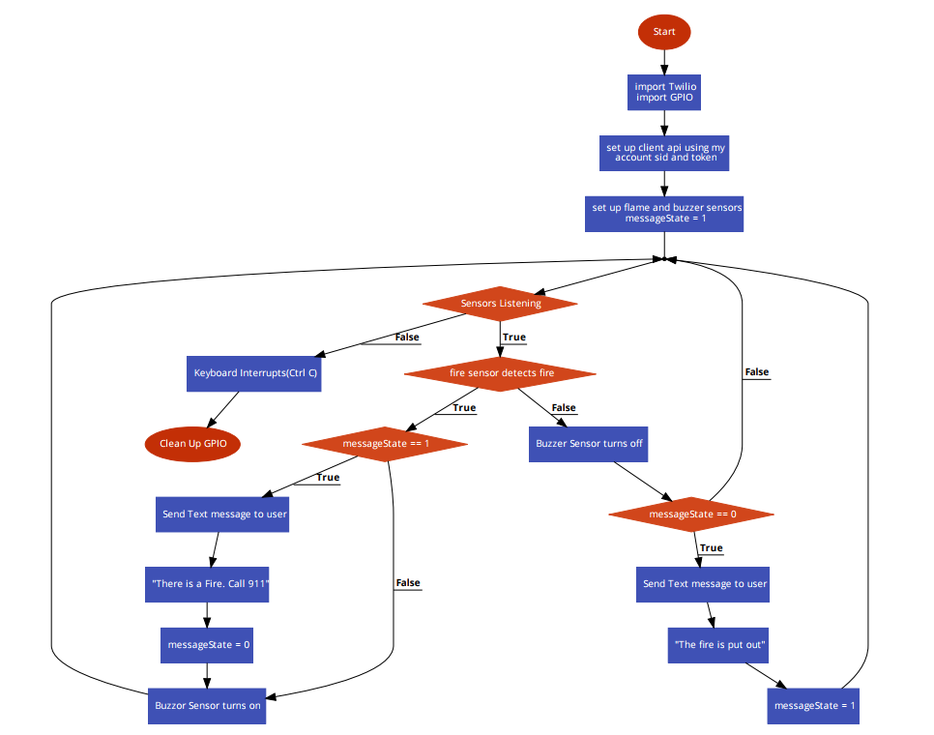Flow chart

**Results**

The user will be notified when there is a fire in their home. I used a lighter showed below to set off the fire alarm showed below. The buzzer sensor turns on and makes noise.

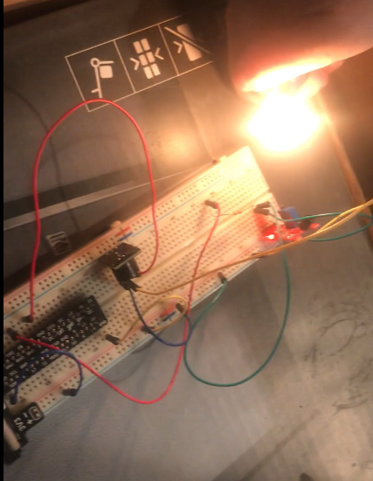

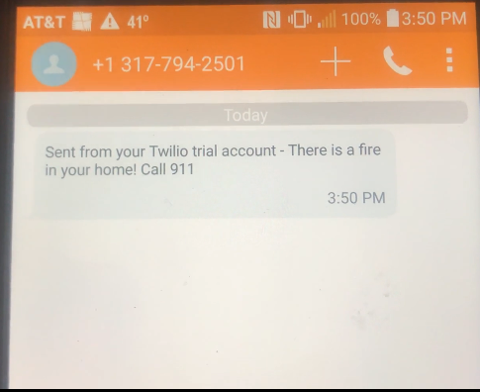Once the lighter was used, it immediately sent a text message saying that there is a fire in the home.

‘

Once the lighter is turned off, the fire is gone. The buzzer will turn off. The fire alarm system will send out another text message that the fire has been put out.

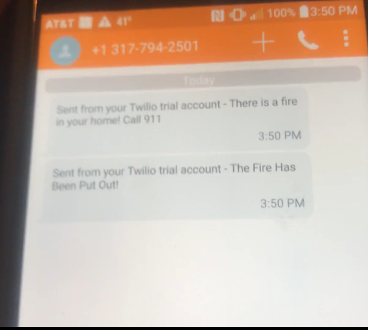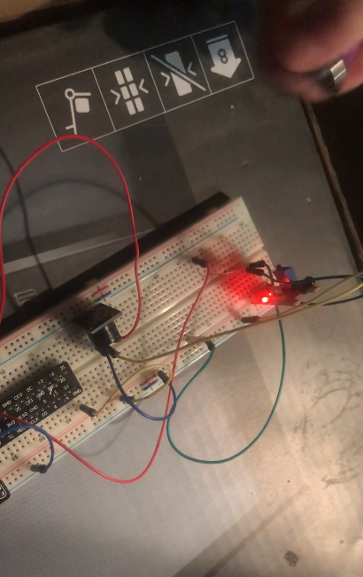

The fire alarm system will continue to send the necessary text messages informing the user if there is a fire in the house and if the fire has been put out. This is important information that the user needs to know to make a decision to call their neighbor or 911.

**Conclusion**

The smart fire alarm system is made for your home. Whenever you leave your home, you do not have to worry about your home being on fire. This is better than having a fire alarm because you do not have to hope that your neighbor hears the fire alarm or that there is nobody at home. You can leave your home knowing that it is safe from fire. This system will help make people’s lives easier knowing that there is no fire in their home using their smart fire alarm system.